Power BI Assignment 3

**1.List and explain different PowerBi Products ?**

Ans:- Microsoft BI tools are designed for easy data processing. That’s putting it a bit simply, but these programs do have a simple objective. The system aims to help businesses turn all of that messy, complex information into extractable insights. It is one of the most popular BI solutions on the market right now.

The full range of tools enables businesses to direct data through IT systems, identify and isolate data, and create expansive reports on the current status of different departments. They include SSIL (SQL Server Integration Services), SSAS (SQL Server Analytical Services) and SSRS (SQL Server Reporting Services).

With these tools, any mass of data can be turned into a digestible report, dashboard, graph, spreadsheet or another format. You just need to input your parameters and let the system know what you need. Microsoft BI software works by moving data from multifarious, unmanageable sources to a centralized architecture where it can be reconfigured.

holds the answers to every question about your business. However, this is far more of a frustration than an asset, unless you decide which questions and answers are valuable. Power BI can help you do this by connecting to live data and providing real-time analytics of trends and market indicators.

The real beauty of Power BI is its near-limitless capacity to mine diverse sources. It can extract insights from much newer SaaS architectures (like Zendesk and Github) just as easily as it can from traditional databases. You can even link the software up to statistical language and have it display complex numerical reports.

The top Microsoft business intelligence tool is its innovative [Power BI](https://www.selecthub.com/business-intelligence-tools/power-bi/?amp=1) service. It’s a curious mix of SaaS, desktop and cloud-based tools.

The different products offered by Microsoft are: [Power BI Desktop](https://powerbi.microsoft.com/en-au/desktop/), [Power BI Pro](https://powerbi.microsoft.com/en-au/power-bi-pro/), [Power BI Premium](https://powerbi.microsoft.com/en-au/power-bi-premium/), [Power BI Mobile](https://powerbi.microsoft.com/en-au/mobile/), [Power BI Embedded](https://azure.microsoft.com/en-us/services/power-bi-embedded/) and [Power BI Report Server](https://powerbi.microsoft.com/en-au/report-server/). Power BI Desktop is the software’s free program, intended for businesses in need of a low-cost report building tool.

Desktop is able to connect to a broad range of databases and various on-premise and cloud-based sources such as [Salesforce](https://www.selecthub.com/crm-software/salesforce/?amp=1), [Dynamics 365](https://www.selecthub.com/crm-software/dynamics-365-crm/?amp=1), Excel, Azure SQL DB. It also publishes visualizations on public online spaces, such as the Power BI service.

Power BI Pro is the next step up. Pro gives users more control over report sharing, with features that enable role-specific data protection, project collaboration and simplified circulation. Power BI Premium is the suite’s top-tier solution. It is made for large-scale data analysis, increased distribution ability and more options for deployment.

Power BI mobile lets you view live dashboards and reports on mobile devices and share them directly with team members from the app. Power BI Embedded allows you to deploy analytics and ensures data security in single and multi-tenant deployments. Power BI Report Server allows you to publish reports on the server and share them with other users.

The central focus of the system is reporting, [data mining](https://www.ibm.com/cloud/learn/data-mining) and exploring. It is able to pinpoint valuable data from a variety of sources and build it up into a report or combine it with others.

Power BI is especially useful for accomplishing reporting tasks through application programming interfaces (APIs). In many ways, Power BI is much like the existing SSRS framework of Microsoft Business Intelligence. It creates intricate layers of data which contribute to the final reporting aspect of business intelligence operations.

The desktop app is great for drawing up and publishing reports. This part of the system is well suited to extracting initial insights. In other words, it can help you determine which questions you need to answer.

To put it another way, your data holds the answers to every question about your business. However, this is far more of a frustration than an asset, unless you decide which questions and answers are valuable. Power BI can help you do this by connecting to live data and providing real-time analytics of trends and market indicators.

**2. What limitations of Excel , Microsoft solved by power Bi**

Ans:- Excel has limitations in the amount of data it can work with. In contrast, Power BI can handle much larger amounts of data. Power BI can connect to a large number of data sources, while Excel's connectivity capacity is limited. Also, unlike Excel, Power BI can be easily used from mobile devices.

* **Excel** is used to **organize data, transform it and perform mathematical operations** and calculations. On the other hand, **Power BI** was conceived as a **business intelligence and**[**data visualization**](https://blog.bismart.com/en/data-visualization-with-power-bi)**tool for businesses**.
* **Excel** has **limitations** in the **amount of data** it can work with. In contrast, **Power BI** **can handle much larger amounts of data**.
* **Power BI can connect to a large number of data sources**, while Excel's connectivity capacity is limited. Also, unlike Excel, Power BI can be easily used from mobile devices.
* **Power BI** has **faster processing** than Excel.
* **Power BI dashboards** are [**more visually appealing, interactive and customizable**](https://blog.bismart.com/en/reporting-services-and-highly-visual-and-interactive-reports) than those in Excel.
* 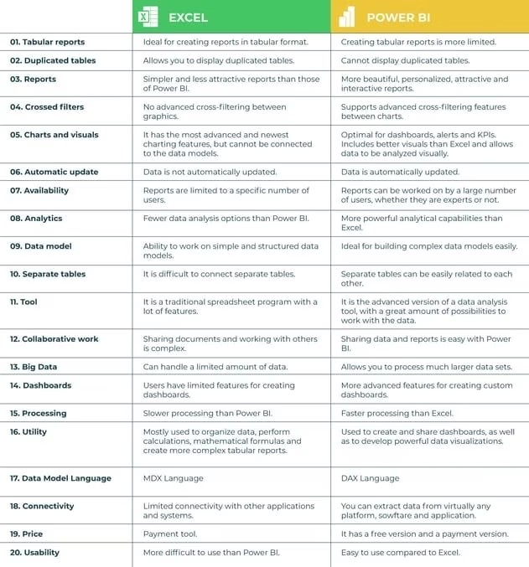Power BI is a more powerful tool than Excel in terms of comparison between tables, reports or data files.
* **Power BI** is more user friendly and **easy to use** than Excel.

**3.Explain Power Query**

**Ans:-**

**Power Query** is an [ETL tool](https://en.m.wikipedia.org/wiki/Extract,_transform,_load) created by [Microsoft](https://en.m.wikipedia.org/wiki/Microsoft) for [data extraction](https://en.m.wikipedia.org/wiki/Data_extraction), loading and [transformation](https://en.m.wikipedia.org/wiki/Data_transformation_(computing)), and is used to retrieve data from sources, process it, and load them into one or more target systems. Power Query is available in several variations within the [Microsoft Power Platform](https://en.m.wikipedia.org/wiki/Microsoft_Power_Platform), and is used for [business intelligence](https://en.m.wikipedia.org/wiki/Business_intelligence) on fully or partially self-service platforms. It is found in software such as [Excel](https://en.m.wikipedia.org/wiki/Microsoft_Excel), [Power BI](https://en.m.wikipedia.org/wiki/Microsoft_Power_BI), [Analysis Services](https://en.m.wikipedia.org/wiki/Microsoft_Analysis_Services), [Dataverse](https://en.m.wikipedia.org/wiki/Microsoft_Dataverse" \o "Microsoft Dataverse),[[1]](https://en.m.wikipedia.org/wiki/Power_Query#cite_note-1) [Power Apps](https://en.m.wikipedia.org/wiki/Power_Apps), [Azure Data Factory](https://en.m.wikipedia.org/wiki/Microsoft_Azure), [SSIS](https://en.m.wikipedia.org/wiki/SQL_Server_Integration_Services), [Dynamics 365](https://en.m.wikipedia.org/wiki/Microsoft_365), and in cloud services such as Microsoft Dataflows,[[2]](https://en.m.wikipedia.org/wiki/Power_Query#cite_note-2) including Power BI Dataflow used with the online Power BI Service or the somewhat more generic version of Microsoft Dataflow used with [Power Automate](https://en.m.wikipedia.org/wiki/Power_Automate).

ETL is closely related to [data modeling](https://en.m.wikipedia.org/wiki/Data_modeling),[[3]](https://en.m.wikipedia.org/wiki/Power_Query#cite_note-3) and for transformation, Power Query can be used to develop a logical data model in those cases where the data does not already have one, or where there is a need to further develop the [data model](https://en.m.wikipedia.org/wiki/Data_model).

Power Query is a data transformation and data preparation engine. Power Query comes with a graphical interface for getting data from sources and a Power Query Editor for applying transformations. Because the engine is available in many products and services, the destination where the data will be stored depends on where Power Query was used. Using Power Query, you can perform the extract, transform, and load (ETL) processing of data. 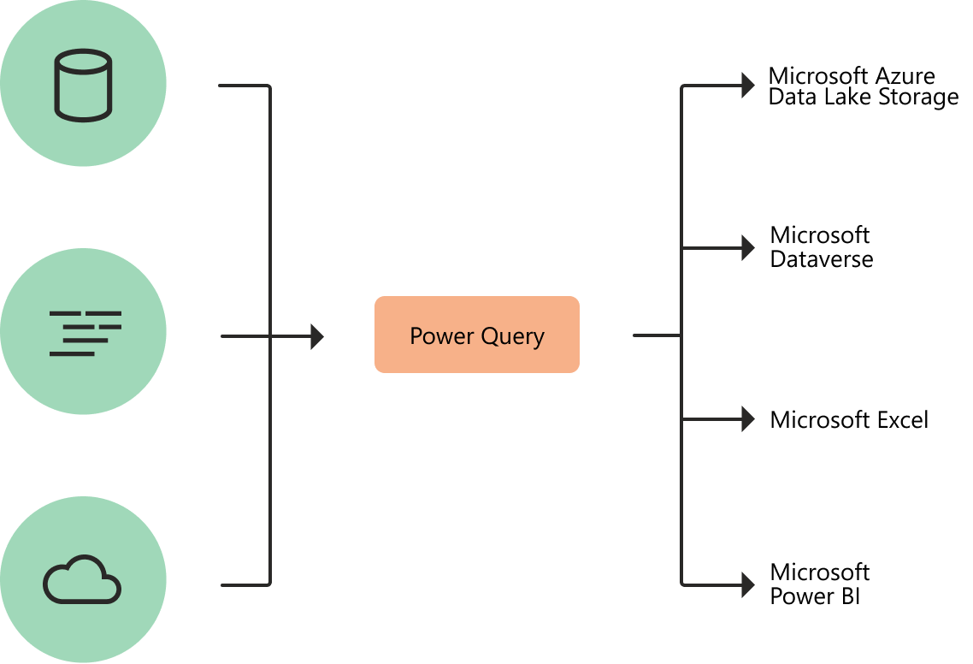

Business users spend up to 80 percent of their time on data preparation, which delays the work of analysis and decision-making. Several challenges contribute to this situation, and Power Query helps address many of them.

| **Existing challenge** | **How does Power Query help?** |
| --- | --- |
| Finding and connecting to data is too difficult | Power Query enables connectivity to a wide range of data sources, including data of all sizes and shapes. |
| Experiences for data connectivity are too fragmented | Consistency of experience, and parity of query capabilities over all data sources. |
| Data often needs to be reshaped before consumption | Highly interactive and intuitive experience for rapidly and iteratively building queries over any data source, of any size. |
| Any shaping is one-off and not repeatable | When using Power Query to access and transform data, you define a repeatable process (query) that can be easily refreshed in the future to get up-to-date data. In the event that you need to modify the process or query to account for underlying data or schema changes, you can use the same interactive and intuitive experience you used when you initially defined the query. |
| Volume (data sizes), velocity (rate of change), and variety (breadth of data sources and data shapes) | Power Query offers the ability to work against a subset of the entire dataset to define the required data transformations, allowing you to easily filter down and transform your data to a manageable size. Power Query queries can be refreshed manually or by taking advantage of scheduled refresh capabilities in specific products (such as Power BI) or even programmatically (by using the Excel object model). Because Power Query provides connectivity to hundreds of data sources and over 350 different types of data transformations for each of these sources, you can work with data from any source and in any shape. |

## Power Query experiences

The Power Query user experience is provided through the Power Query Editor user interface. The goal of this interface is to help you apply the transformations you need simply by interacting with a user-friendly set of ribbons, menus, buttons, and other interactive components.

The Power Query Editor is the primary data preparation experience, where you can connect to a wide range of data sources and apply hundreds of different data transformations by previewing data and selecting transformations from the UI. These data transformation capabilities are common across all data sources, whatever the underlying data source limitations.

When you create a new transformation step by interacting with the components of the Power Query interface, Power Query automatically creates the M code required to do the transformation so you don't need to write any code.

Currently, two Power Query experiences are available:

* **Power Query Online**—Found in integrations such as Power BI dataflows, Microsoft Power Platform dataflows, Azure Data Factory wrangling dataflows, and many more that provide the experience through an online webpage.
* **Power Query for Desktop**—Found in integrations such as Power Query for Excel and Power BI Desktop.

**4.Explain Power Map ?**

**Ans:- Power Map** in Power BI is a **3D data visualization tool** that allows you to explore and analyze your data in a dynamic and immersive way. It lets you plot geographical and temporal data on a globe or custom map, creating visually striking presentations that enhance your data storytelling.

Here are some key features of Power Map:

* **3D Visualization:**
* View your data points on a 3D globe or any custom map you choose.
* Zoom in and out, rotate the map, and explore your data from different angles.
* Add layers of information like countries, cities, roads, and buildings.
* **Temporal Analysis:**
* Play your data over time, watching trends and patterns unfold visually.
* Highlight specific time periods of interest and compare them side-by-side.
* Use animation to see how your data changes over time.
* **Customization and Interaction:**
* Modify the appearance of your map with different styles and themes.
* Change the size and color of data points based on their values.
* Add tooltips and labels to provide additional information on hover.
* Filter and segment your data to focus on specific areas or categories.
* **Integration with Power BI:**
* Power Map is seamlessly integrated with the Power BI ecosystem.
* Connect to various data sources directly from within Power Map.
* Use DAX calculations to manipulate your data and create custom visualizations.
* Share your Power Maps as part of your Power BI reports and dashboards.

**Benefits of using Power Map:**

* **Enhanced understanding:** 3D visualization can reveal hidden patterns and relationships that might be missed in traditional graphs and charts.
* **Engaging storytelling:** Create visually captivating presentations that grab attention and effectively communicate insights.
* **Improved collaboration:** Share your interactive Power Maps with others to foster collaborative data exploration and decision-making.
* **Greater accessibility:** Make your data more accessible and engaging for diverse audiences.

**However, it's important to consider some limitations:**

* **Performance:** Large datasets may experience performance issues in Power Map.
* **Limited chart types:** Power Map focuses on 3D representations and offers fewer traditional chart options.
* **Learning curve:** Mastering Power Map requires some learning and practice.

**Overall, Power Map is a powerful tool for enhancing data visualization and storytelling in Power BI. If you want to add a new dimension to your data analysis and create stunning presentations, Power Map is definitely worth exploring.**

**5. How power Bi eliminated the need to host share Point server on premises?**

**Ans:-** [SharePoint](https://products.office.com/sharepoint/collaboration) is an important part of how many organizations organize and distribute BI content to users. In recognition of how important this approach is, we’ve invested in modernizing and creating deeper integrations with SharePoint. Over the last year, we have introduced the [Power BI webpart for SharePoint Online](https://docs.microsoft.com/power-bi/service-embed-report-spo) and an updated [Reporting Services Report Viewer webpart](https://blogs.msdn.microsoft.com/sqlrsteamblog/2017/09/22/embed-paginated-reports-into-sharepoint-using-the-report-viewer-web-part/) for SharePoint on-premises. Customers like the flexibility this gives them to build highly-customized SharePoint experiences using their BI content.

[SharePoint](https://products.office.com/sharepoint/collaboration) is an important part of how many organizations organize and distribute BI content to users. In recognition of how important this approach is, we’ve invested in modernizing and creating deeper integrations with SharePoint. Over the last year, we have introduced the [Power BI webpart for SharePoint Online](https://docs.microsoft.com/power-bi/service-embed-report-spo) and an updated [Reporting Services Report Viewer webpart](https://blogs.msdn.microsoft.com/sqlrsteamblog/2017/09/22/embed-paginated-reports-into-sharepoint-using-the-report-viewer-web-part/) for SharePoint on-premises. Customers like the flexibility this gives them to build highly-customized SharePoint experiences using their BI content.

6.Explain The Update done in Power Bi service (Power Bi 2.0 ) as Compared to older version ?

Ans:-

Let’s see what is new in Power BI.

# Get Data

* Sign into Power BI
* Click on Get Data button from the bottom of the left navigation pane
* There are now two different sections in the “Get Data” of your workspace which each of them have two parts:

1. Content Pack Library
   * My Organisation: from here you can easily create you organisational content packs. A content pack is basically a single repository to keep dataests, reports, dashboards, Q&A, integration with other data sources, data refresh and more. You can also package up and publish your dashboards, reports and datasets with your colleagues in a specific group or the entire organisation. You can also browse the content packs that other people in your organisation published.
   * Services: you can use lots of online services built to connect to different platforms like Microsoft Dynamics CRM, Microsoft Dynamics Marketing, Visual Studio Online , and much more.
2. Import Or Connect to Data
   * Files: You can upload your reports, data or workbooks from Excel, Power BI Desktop or CSV files. The location of the files could be your local hard drive, on OneDrive Business or OneDrive Personal.
   * Databases: You can connect to Azure SQL Database, Azure SQL Data Warehouse, SQL Server Analysis Services Tabular Model or Azure HDInsight (Spark) and browse your live data.

#### Content pack Library – My Organisation

* From Get Data click on “My Organisation”

[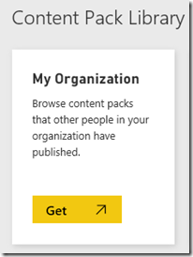](https://i0.wp.com/www.biinsight.com/wp-content/uploads/2015/07/image121.png?ssl=1)

* As you can see there is a brief definition of “My Organisation” which is “MY ORGANISATION IS WHERE YOU CAN FIND CONTENR PACKS PUBLISHED BY YOU AND OTHER IN YOUR ORGANISATION”
* Click “Create Content Pack”

[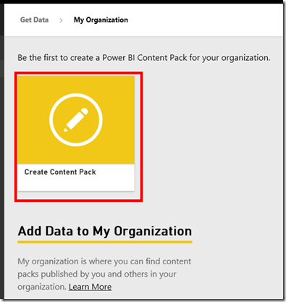](https://i0.wp.com/www.biinsight.com/wp-content/uploads/2015/07/image151.png?ssl=1)

* Choose who will have access to this content pack. If you choose “My Entire Organisation”  then you just need to type a title as well as description for the content pack then click Publish. If you want to publish the content pack with specific groups then you need to enter email addresses separated by semicolon (;) or comma (,)
* Select the items you want to publish. If you select a dashboard it will automatically select all corresponding reports and datasets.
* You can also upload a company logo or image by clicking on Upload link
* Click Publish

# Reports

The report’s features are improved significantly. We can know change the chart’s colours, adding free texts into TextBoxes and much more.

#### Power BI for Office 365

This is another cool feature which is newly added. Now you can easily switch to your Power BI for Office 365 account. There is also a link for Power BI which is newly added to Power BI 365.